COMPUTER:

A computer is a programmable electronic device that accepts raw data and instruction from input device, process data and provides output as information in output device.

COMPUTER SYSTEM:

A computer system consists of two major components, namely, **hardware and software**. All physical components that forms computer system are known as **computer hardware**. Software is basically **collection of different programs** that tells computer’s hardware what to do.

HARDWARE:

All physical components that make up a computer is known as computer hardware. It includes all components that we can see and touch i.e. processor, input devices like keyboard, mouse, output devices like visual display unit (VDU), printer, speaker, connecting wires, casing, storage devices etc. Block diagram depicting major components of computer is shown below:

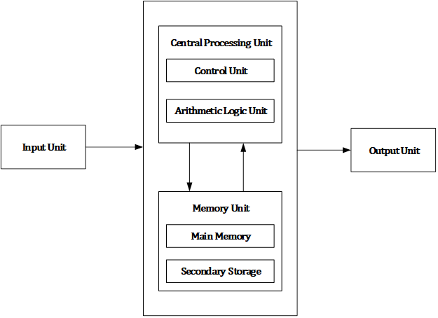

Figure: Computer Block Diagram

Computer hardware consists of different functional units: input unit, central processing unit (CPU) which consists arithmetic logic unit (ALU) and control unit (CU), memory unit and output unit. Computer accepts digital data from user with the help of input devices like mouse, keyboard, microphone etc. Received data from user is either stored in the memory for later use or immediately processed by the arithmetic and logic unit to carry out the desired operations. After processing, processed output known as information is either stored in memory for later use or sent to user with the help of output devices like monitor, printer, speaker etc. All the above mentioned activities are controlled and coordinated by the control unit.

MOTHERBOARD:

The motherboard is at the center of what makes a PC work. It houses the CPU and is a hub that all other hardware runs through. The motherboard acts as a brain; allocating power where it’s needed, communicating with and coordinating across all other components – making it one of the most important pieces of hardware in a computer. When choosing a motherboard, it’s important to check what hardware ports the motherboard supplies. It’s vital to check how many USB ports, and what grade (USB 2.0, 3.0, 3.1) they are, as well as what display ports are used (HDMI, DVI, RGB) and how many of each there are. The ports on the motherboard will also help you define what other hardware will be compatible with your computer, such as what type of RAM and graphics card you can use. Although the motherboard is just one piece of circuitry, it is home to another one of the most important pieces of hardware: the processor.

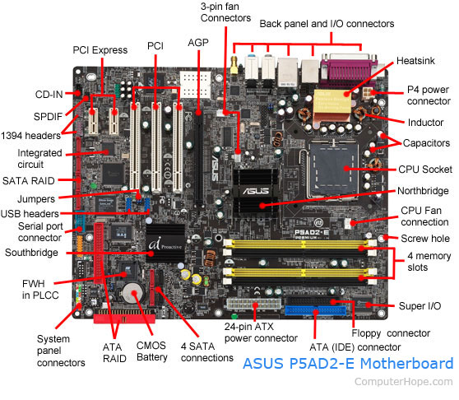

RAM:

Random Access Memory, or RAM, is hardware found in the memory slots of the motherboard. The role of RAM is to temporarily store on-the-fly information created by programs and to do so in a way that makes this data immediately accessible. The tasks that require random memory could be; rendering images for graphic design, edited video or photographs, multi-tasking with multiple apps open (for example, running a game on one screen and chatting via Discord on the other).

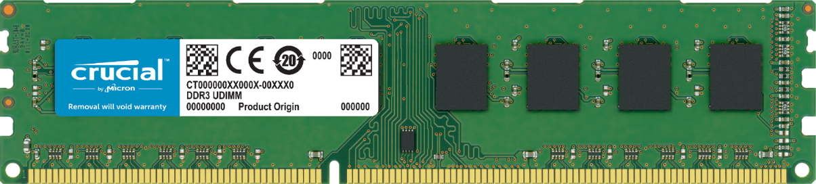

**RAM**, which stands for random-access memory, which temporarily stores data while the central processing unit (CPU) is executing other tasks. With more RAM on the computer, the less the CPU has to read data from the external or secondary memory (storage device), allowing the computer to run faster. RAM is fast but it is volatile, which means it will not retain data if there is no power. It is therefore important to save data to the storage device before the system is turned off.

There are two main types of RAM: Dynamic RAM (DRAM) and Static RAM (SRAM).

* **DRAM**(pronounced DEE-RAM), is widely used as a computer’s main memory. Each DRAM memory cell is made up of a transistor and a capacitor within an integrated circuit, and a data bit is stored in the capacitor. Since transistors always leak a small amount, the capacitors will slowly discharge, causing information stored in it to drain; hence, DRAM has to be refreshed (given a new electronic charge) every few milliseconds to retain data.
* **SRAM**(pronounced ES-RAM) is made up of four to six transistors. It keeps data in the memory as long as power is supplied to the system unlike DRAM, which has to be refreshed periodically. As such, SRAM is faster but also more expensive, making DRAM the more prevalent memory in computer systems. 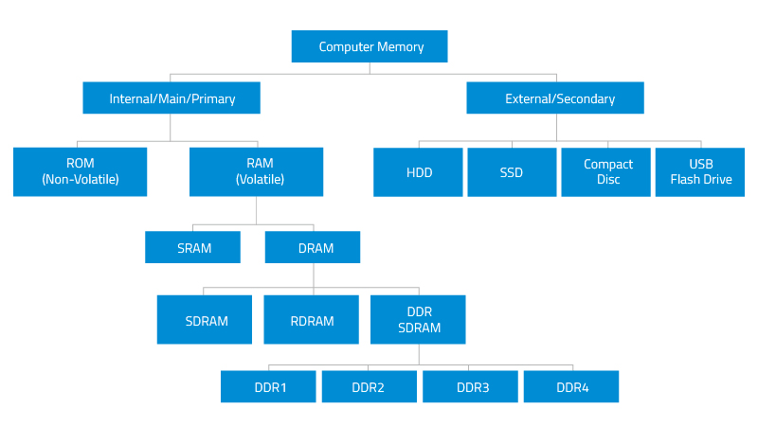

DAUGHTER CARD:

A daughter card or [daughterboard](https://www.easytechjunkie.com/what-is-a-daughterboard.htm) is a type of [circuitboard](https://www.easytechjunkie.com/what-is-a-circuit-board.htm) that gets added to an existing one. Its name is appropriate for its use, since it is connected to a “[**motherboard**](https://www.easytechjunkie.com/what-is-a-motherboard.htm)” or “main board.” The motherboard is the primary circuit board for a device. It is usually in the device as it is shipped from the factory. A daughter card may be added later. Some daughter card designs are made so that engineers can add functionality to a device without requiring a lot more room inside its housing. These kinds of items are often called riser boards or risers. Some might also call them “mezzanine boards.” Daughter cards are different from some other types of additional circuit boards that tech enthusiasts call “expansion cards.” In expansion cards, the circuit board is often plugged in through a gap in the housing of a computer or device. These expansion boards help to give a device more functionality, often for additional sound play or for better visuals on a high-tech monitor or screen. In contrast to the way expansion boards are used, a daughter card can be a more fundamental enhancement for a device. Adding a daughter card often requires getting into the guts of a device. That’s why some users might hire a professional to install it. Companies that make an electronic device might offer a daughter card as part of an essential upgrade that allows the product to be used in more various ways.

BUS SLOTS:

 A **bus slot** or **expansion port**, an **expansion slot** is connection or port located inside a computer on the motherboard or riser board that allows a computer hardware expansion card to be connected. For example, if you wanted to install a new video card in the computer, you’d purchase a video expansion card and install that card into the compatible expansion slot.

Many of the below expansion card slots are obsolete. You’re most likely only going to encounter AGP, PCI, and PCI Express when working with computers today. In the picture below is an example of what expansion slots may look like on a motherboard. In this picture, there are three different types of expansion slots:**PCI Express**, **PCI**, and **AGP**.

* **PCI** – Network card, SCSI, Sound card, Video card
* **PCI Express** – Video card
* **AGP** – Video card
* **ISA** – Network card, Sound card, Video card
* **AMR** – Modem, Sound card
* **CNR** – Modem, Network card, Sound card
* **EISA** – SCSI, Network card, Video card
* **VESA** – Video card

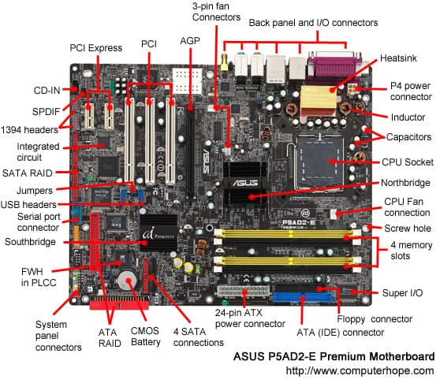

**PCI Express:**The best type of expansion slot to have in your PC is the PCI Express, also written as PCIe. Without boring you, the PCI Express type of expansion slot communicates with the motherboard, and therefore with the microprocessor, both quickly and efficiently.

**PCI:** The PCI slot is the most common form of internal expansion for a PC. Some PCs have a mixture of PCI and PCI Express slots. If so, go with PCI Express when you have that option.

**AGP:**This type of expansion slot was specifically designed to deal with graphics adapters. In fact, AGP stands for Accelerated Graphics Port. Older PCs may sport this expansion slot, but the best video cards use PCI Express.

**ISA:**The most ancient type of expansion slot is the ISA, which stands for (get this) Industry Standard Architecture. That’s because it never really had a name until another, better type of expansion slot came along. ISA slots hang around to be compatible with older expansion cards.

#### PCI slot

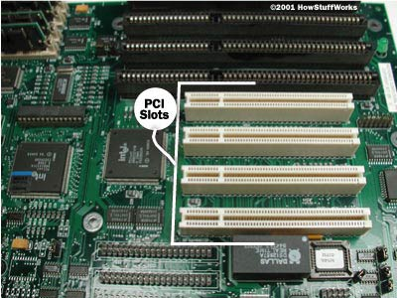

#### PCI card

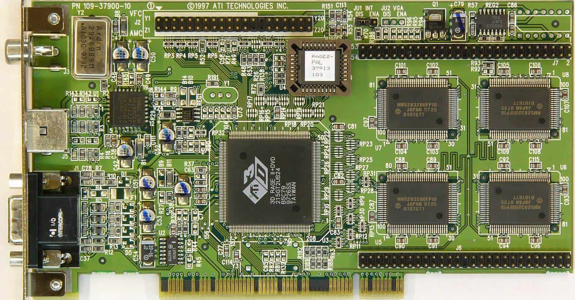

#### PCI-e slot (x16)

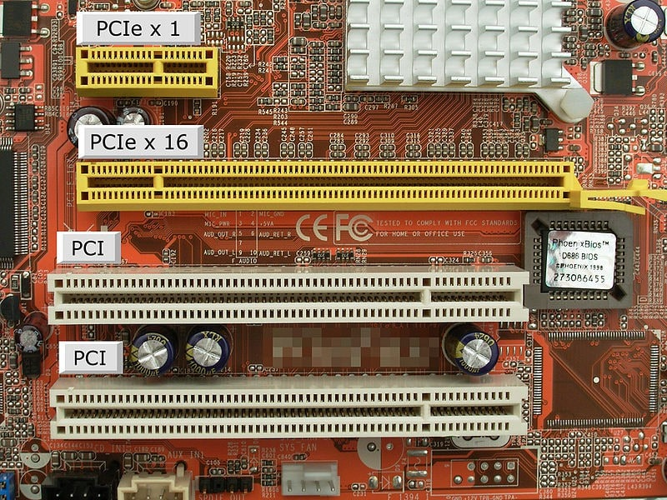

#### PCI-e card (x16)

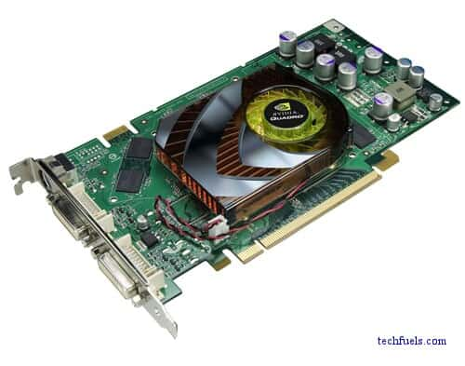

AGP SLOT

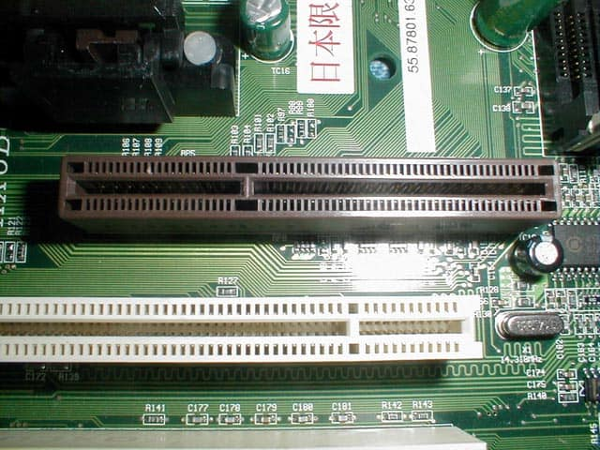

#### AGP card

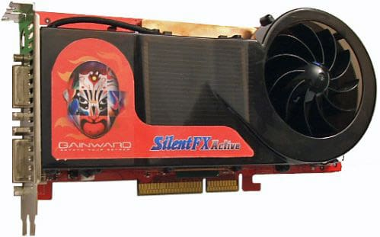

## SMPS: Switched-Mode Power Supply/ Switching Mode Power Supply

SMPS stands for Switched-Mode Power Supply. It is an electronic power supply that uses a switching regulator to convert electrical power efficiently. It is also known as Switching Mode Power Supply. It is power supply unit (PSU) generally used in computers to convert the voltage into the computer acceptable range.This device has the power handling electronic components that converts electrical power efficiently. Switched Mode Power Supply uses a great power conversion technique to reduce overall power loss.

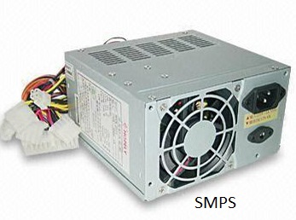

The SMPS device uses switching regulators that switches the load current on and off to regulate and stabilize the output voltage. The average of the voltage between the off and on produces the appropriate power for a device. Unlike the linear power supply, the pass transistor of SMPS switches between low dissipation, full-on and full-off mode, and spends very less time in the high-dissipation transitions, which minimizes wasted energy.

**INTERNAL STORAGE DEVICES**

**(i) RAM:**It stands for Random Access Memory. It is used to store information that is used immediately or we can say that it is a temporary memory. Computers bring the software installed on a hard disk to RAM to process it and to be used by the user. Once, the computer is turned off, the data is deleted. With the help of RAM, computers can perform multiple tasks like loading applications, browsing the web, editing a spreadsheet, experiencing the newest game, etc. It allows you to modify quickly among these tasks, remembering where you’re in one task once you switch to a different task. It is also used to load and run applications, like your spreadsheet program, answer commands, like all edits you made within the spreadsheet, or toggle between multiple programs, like once you left the spreadsheet to see the email. Memory is nearly always being actively employed by your computer. It ranges from 1GB – 32GB/64GB depending upon the specifications. There are different types of RAM, although they all serve the same purpose, the most common ones are:

* **SRAM:**It stands for Static Random Access Memory. It consists of circuits that retain stored information as long as the power is supply is on. It is also known as volatile memory. It is used to build Cache memory. The access time of SRAM is lower and it is much faster as compared to DRAM but in terms of cost, it is costly as compared to DRAM.
* **DRAM:**It stands for Dynamic Random Access Memory. It is used to stores binary bits in the form of electrical charges that are applied to capacitors. The access time of DRAM is slower as compare to SRAM but it is cheaper than SRAM and has a high packaging density.
* **SDRAM:**It stands for Synchronous Dynamic Random Access Memory. It is faster than DRAM. It is widely used in computers and others. After SDRAM was introduced, the upgraded version of double data rate RAM, i.e., DDR1, DDR2, DDR3, and DDR4 was entered into the market and widely used in home/office desktops and laptops.

**(ii) ROM:**It stands for Read-Only Memory. The data written or stored in these devices are non-volatile, i.e, once the data is stored in the memory cannot be modified or deleted. The memory from which will only read but cannot write it. This type of memory is non-volatile. The information is stored permanently during manufacture only once. ROM stores instructions that are used to start a computer. This operation is referred to as bootstrap. It is also used in other electronic items like washers and microwaves. ROM chips can only store few megabytes (MB) of data, which ranges between 4 and 8 MB per ROM chip. There are two types of ROM:

* **PROM:**PROM is Programmable Read-Only Memory. These are ROMs that can be programmed. A special PROM programmer is employed to enter the program on the PROM. Once the chip has been programmed, information on the PROM can’t be altered. PROM is non-volatile, that is data is not lost when power is switched off.
* **EPROM:** Another sort of memory is that the Erasable Programmable Read-Only Memory. It is possible to erase the info which has been previously stored on an EPROM and write new data onto the chip.

INTERFACING PORTS

A port is a physical docking point using which an external device can be connected to the computer. It can also be programmatic docking point through which information flows from a program to the computer or over the Internet.

## Characteristics of Ports

A port has the following characteristics −

* External devices are connected to a computer using cables and ports.
* Ports are slots on the motherboard into which a cable of external device is plugged in.
* Examples of external devices attached via ports are the mouse, keyboard, monitor, microphone, speakers, etc.

Serial Port

* Used for external modems and older computer mouse
* Two versions: 9 pin, 25 pin model
* Data travels at 115 kilobits per second
* 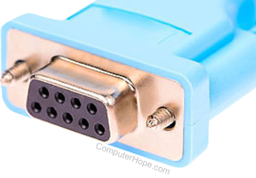

Parallel Port

* Used for scanners and printers
* Also called printer port
* 25 pin model
* IEEE 1284-compliant Centroids port
* 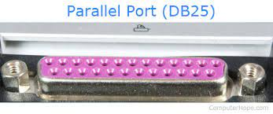

PS/2 Port

* Used for old computer keyboard and mouse
* Also called mouse port
* Most of the old computers provide two PS/2 port, each for the mouse and keyboard
* IEEE 1284-compliant Centronics port
* 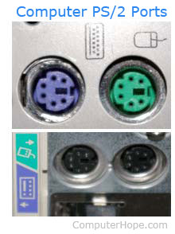

Universal Serial Bus (or USB) Port

* It can connect all kinds of external USB devices such as external hard disk, printer, scanner, mouse, keyboard, etc.
* It was introduced in 1997.
* Most of the computers provide two USB ports as minimum.
* Data travels at 12 megabits per seconds.
* USB compliant devices can get power from a USB port.
* 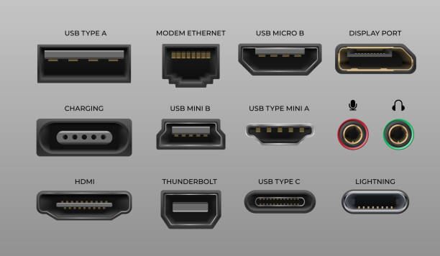

VGA Port

* Connects monitor to a computer's video card.
* It has 15 holes.
* Similar to the serial port connector. However, serial port connector has pins, VGA port has holes.
* 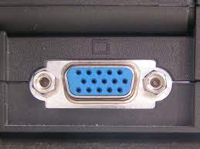

Power Connector

* Three-pronged plug.
* Connects to the computer's power cable that plugs into a power bar or wall socket.

Fire wire Port

* Transfers large amount of data at very fast speed.
* Connects camcorders and video equipment to the computer.
* Data travels at 400 to 800 megabits per seconds.
* Invented by Apple.
* It has three variants: 4-Pin FireWire 400 connector, 6-Pin FireWire 400 connector, and 9-Pin FireWire 800 connector.

Modem Port

* Connects a PC's modem to the telephone network.

Ethernet Port

* Connects to a network and high speed Internet.
* Connects the network cable to a computer.
* This port resides on an Ethernet Card.
* Data travels at 10 megabits to 1000 megabits per seconds depending upon the network bandwidth.

Game Port

* Connect a joystick to a PC
* Now replaced by USB

Digital Video Interface, DVI port

* Connects Flat panel LCD monitor to the computer's high-end video graphic cards.
* Very popular among video card manufacturers.

Sockets

* Sockets connect the microphone and speakers to the sound card of the computer.

SERVER CLASS COMPUTERS

When multithreaded operating system processes are not available, a good alternative is to use a set of processes to emulate a pool of threads. That is, instead of having one [multithreaded process](https://www.sciencedirect.com/topics/computer-science/multithreaded-process), the system uses a set of single-threaded processes, all of which are running the same program (see Figure 2.8). This often is called a **server class**. In this case, for each server program, there is a set of server processes that runs it.

Server classes have a number of nice features. Most of them stem from the fact that each process in the server class is an ordinary single-threaded process and therefore avoids the disadvantages of multithreading, such as the following:

■

Since the process is single-threaded, there’s no harm in putting it to sleep if it is blocked during a synchronous I/O operation. Therefore, there is no need for the [transactional middleware](https://www.sciencedirect.com/topics/computer-science/transactional-middleware) to trap synchronous I/O; the normal blocking behavior of the operating system is just fine.

There’s no possible conflict between process and thread scheduling and no possible memory corruption problems from threads in the same process.

Processes in a server class fail independently. That is, a server class is largely unaffected by the failure of any individual process in the server class, since other processes continue to run. This is in contrast to a multithreaded process, where the failure of one thread can bring down the whole process, especially if it corrupts the memory of other threads.

Each process in a server class can use single-threaded services, such as a single-threaded database system that executes as a [runtime library](https://www.sciencedirect.com/topics/computer-science/runtime-library). This was an important benefit before the advent of multithreaded database systems.

For these reasons, and to avoid the expense of implementing multithreading, server classes were quite popular in transactional middleware products before the advent of multithreaded operating systems, as in the case of HP’s ACMS and Pathway legacy [TP](https://www.sciencedirect.com/topics/computer-science/transaction-processing) monitors.

However, server classes do have disadvantages.

One is that there is a process per thread. As we explained earlier, operating systems don’t work well with too many processes. So server classes can be used only when the number of required server threads is relatively small.

Another disadvantage of server classes is that they require an additional mechanism to dispatch calls to the server class to a particular server process. The problem is how to balance the load across the servers in the server class. The caller could randomize its selection of server, thereby balancing the load across multiple servers, on the average. Or, the processes in the server class could share a queue of unprocessed requests. If a busy process receives a call, it simply adds it to the queue, where another process can pick it up. Or, the server class could have a single process that receives all requests and routes each one to an idle process. The latter is easy to implement, but costs an extra context switch, since each call has to invoke the server class’s router process before going to a server.

SPECIFICATIONS OF DESKTOP

Computer hardware specifications are technical descriptions of the computer's components and capabilities.

* Processor speed, model and manufacturer. Processor speed is typically indicated in gigahertz (GHz). The higher the number, the faster the computer.
* Random Access Memory (RAM), this is typically indicated in gigabytes (GB). The more RAM in a computer the more it can do simultaneously.
* Hard disk (sometimes called ROM) space.  This is typically indicated in gigabytes (GB) and refers generally to the amount of information (like documents, music and other data) your computer can hold.
* Other specifications might include network (Ethernet or Wi-Fi) adapters or audio and video capabilities.